**E -Cube Web application**

**By- Sai Nikhil Reddy K**

**Web application documentation:**

**=> Code documentation :**

Used Vscode(IDE), ReactJs, Bootstrap classes, basic CSS, json-server and other libraries to achieve the functionalities to create the web application in my style.

To initiate this project, open CMD, (nodejs is already installed), used below command

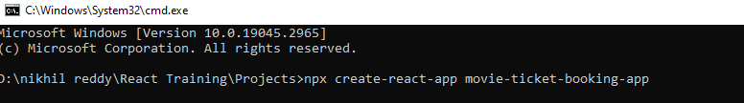

Project with basic dependencies is created.

Once opened the project folder, inside index.html, included the bootstrap cdn’s.

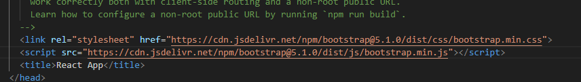

At first for routing , redux, axios usage I have installed the libraries.

**npm i react-router-dom redux react-redux axios**

**To start the project run:**

**=> npm install** (wait for dependencies to install)

=>run the json server **(npx json-server –port 4000 –watch db.json)**

**=> npm start** (to start the application)

**\*\* make sure to run the JSON_SERVER on port 4000**

**=> Project Structure (file/folder organization):**

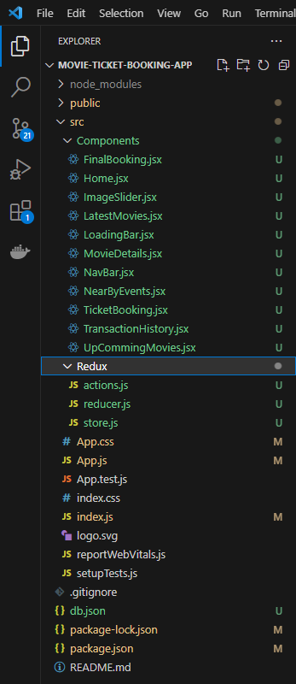 **this image shows the files and folder structure of the project**

I have used all the main screen files inside the component folder of src( “/src/Components”)

For redux related stuff, I have used the Redux folder and placed the js file inside it.(“src/Redux”)

**Route Paths configured in app.js :**

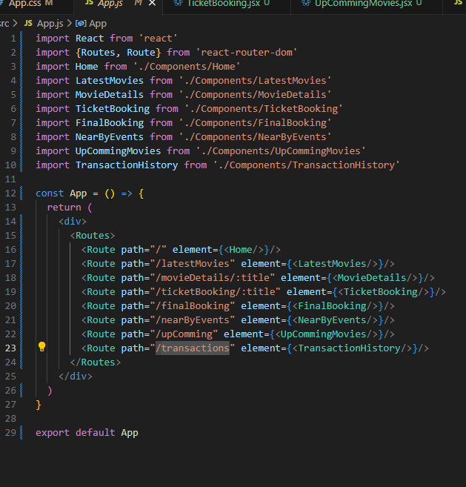

**Screens:**

**Home screen :**

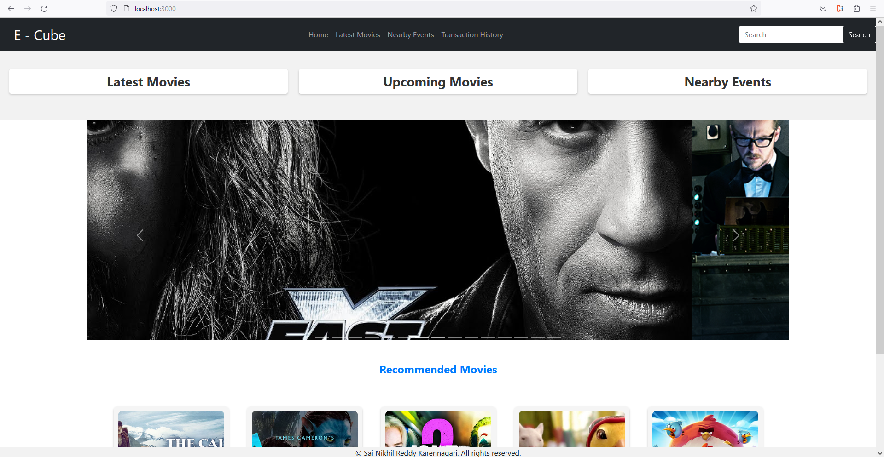

In the home screen, I have added the navigation bar, search button in navigation bar, a section for latest movies, upcoming movies, nearby events, a section of image slider(used carousel from react-bootstrap), a section for recommended movies and a footer section for copyrights.

On click of latest movies banner or on the navigation, it will redirect to the latest movies page.

**Latest Movies Screen:**

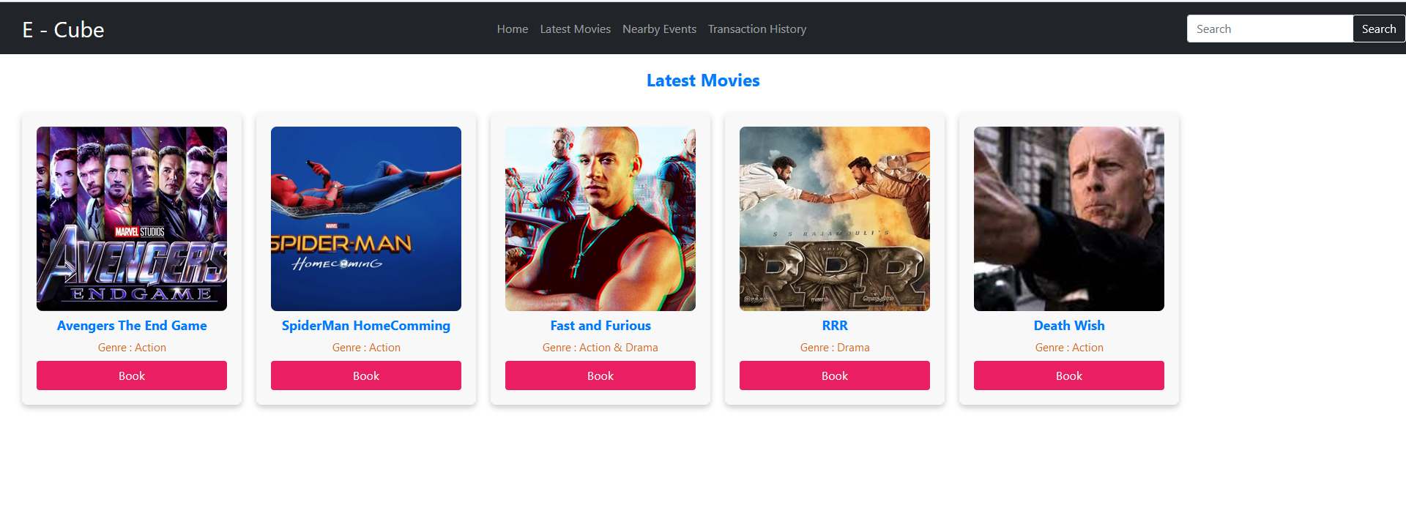

Here in the page, we show all the latest movies, with an option to book the tickets for movies.

**Recommended movies:**

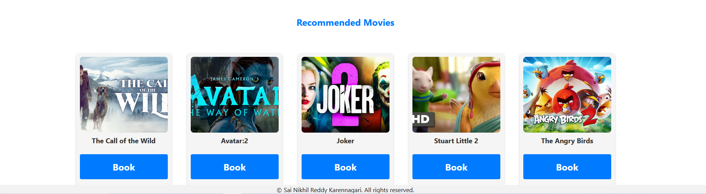

This section also has the recommended movies and option to book the tickets

On Click of Book button from recommendations or latest movies page we redirect to ticket booking page.

**Ticket Booking screen:**

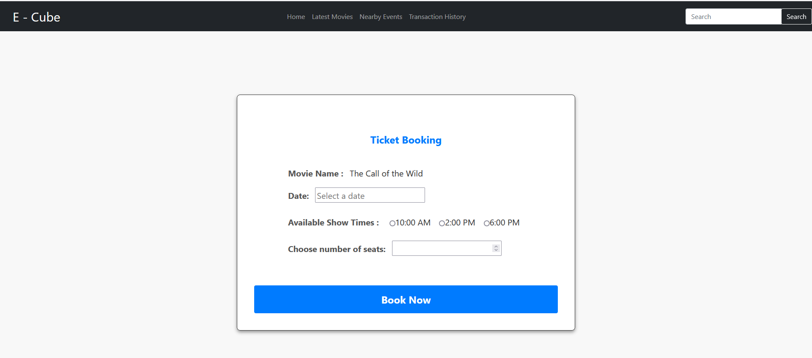

This page takes inputs from the user and allows to book the tickets with basic information required.( we are passing the movie name to navigate to that particular ticket booking page).

Here few validations are taken care and on click of the book now button , we will confirm the booking of tickets and redirect to **final booking page**.

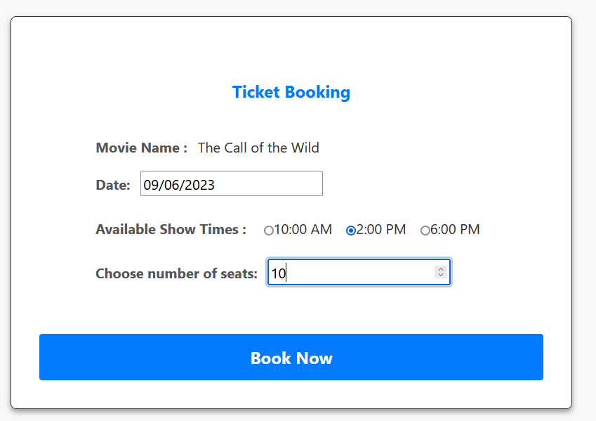

**Final Booking page:**

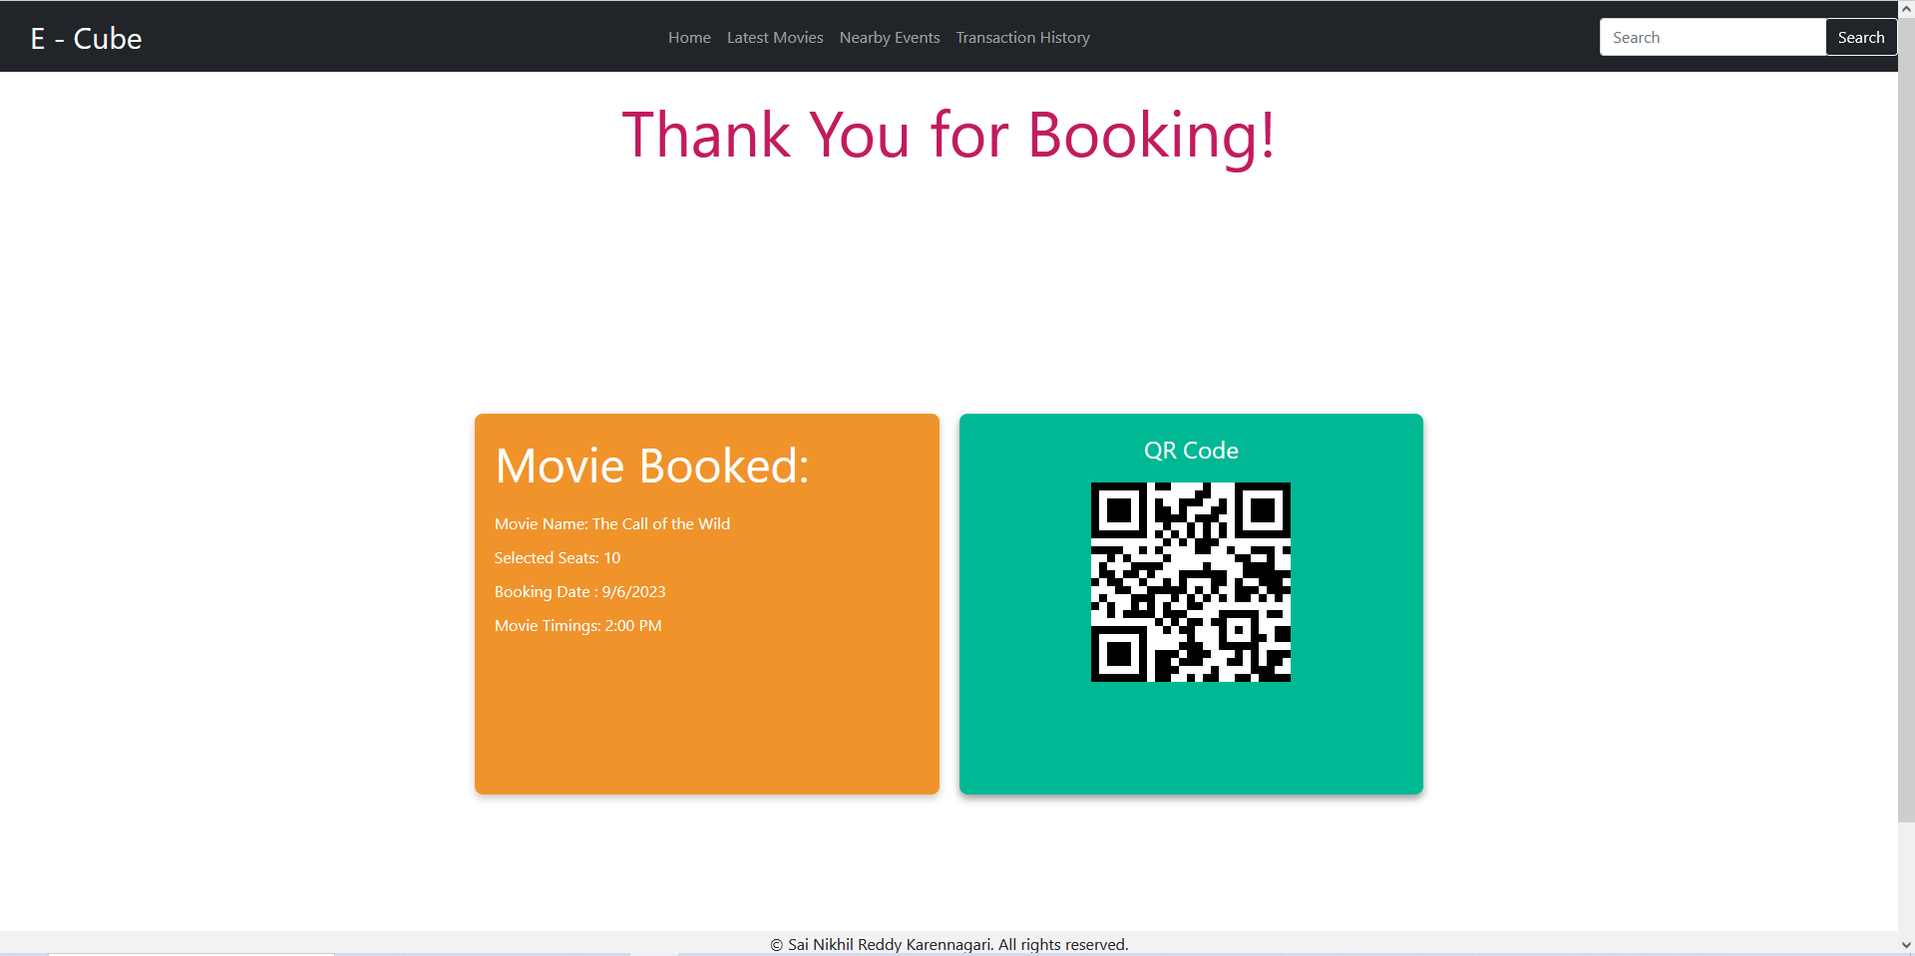

Now a final booking page appears, where the booking was successful and shows the ticket details along with bookingID QR code. If we scan the QR code , we can get the bookingID.

We can also check our transaction from transaction history page.

**Transaction History page:**

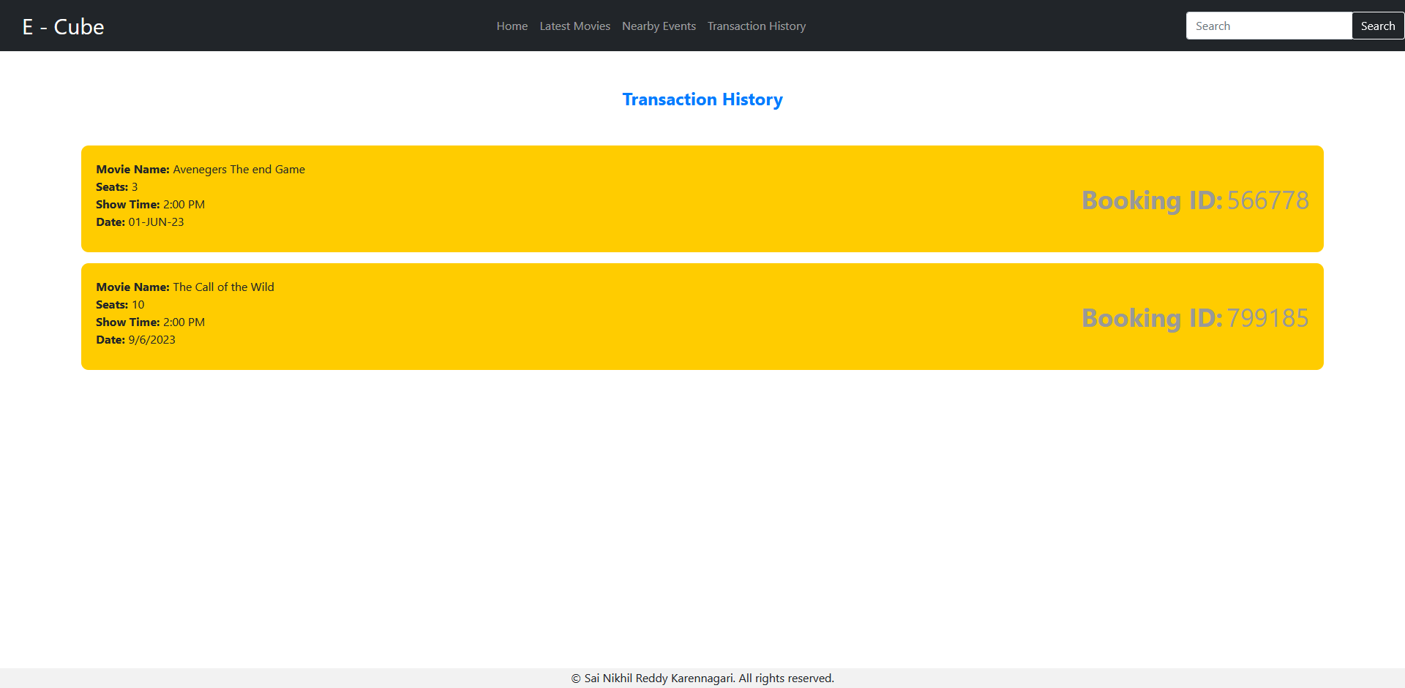

Information of your previous bookings will be shown here.

**Near By Events screen:**

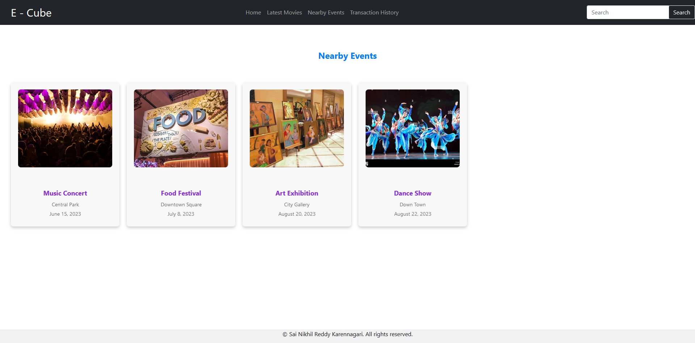

This screen will show all the near by events and live events going on.

**Movie Details Page:**

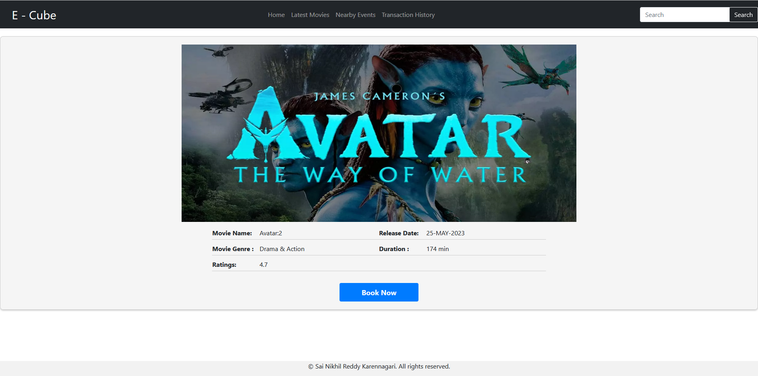

When we click on any movie or search from navigation, we end up at the details of the movie page.

**DATA Maintenance:**

All the data are stored in db.json file. Using the json-server with endpoints.

**There are 3 api’s:**

<http://localhost:4000/movieDetails> (for latest movies, upcoming movies, recommended movies)

<http://localhost:4000/nearByEvents> (for near by events)

<http://localhost:4000/transactions> ( for transaction details)

**Redux Code:**

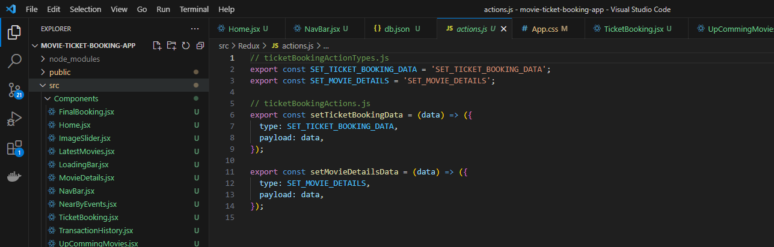

Action.js has the action creators for setting the ticket info and setting the movie details got from the api.

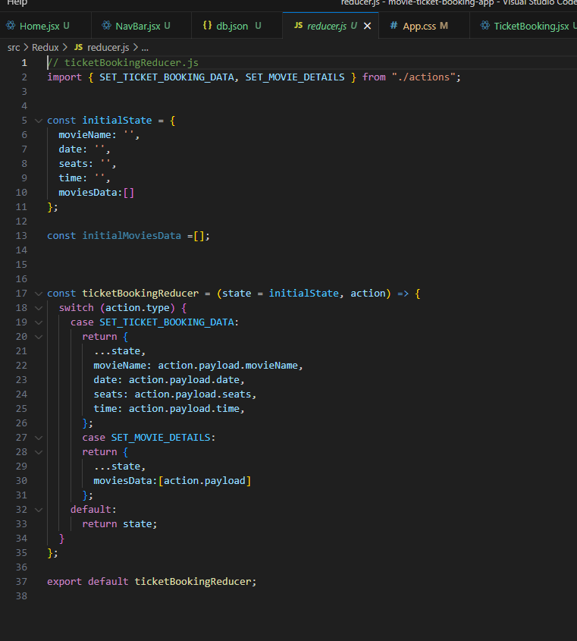 reducer function

**Store:**

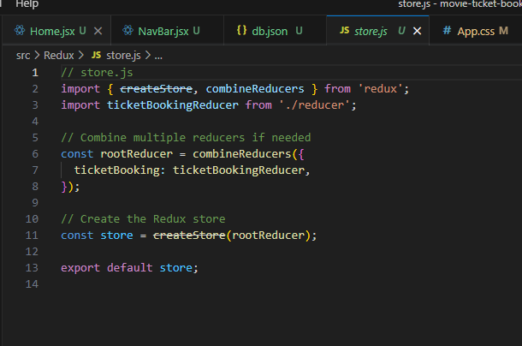

Using the json server was able to retrieve the data using axios get call and dispatching the function to set the movie details in the home page, so this data is accessible to all the components.

**Styling:**

=> App.css has all the styling for the application.

=> created a loading component to show the loading status symbol on api calls and navigations.

=> used react-carousel for image sliders

=> used react-qr-code to generate a qr code based on the booking id

=> used react-datepicker for selection of date params in the input field of date while ticket booking.

=> used bootstrap classes and basic css to style the components